**Institute of Technology Tralee**

**Ord/Hons BSc. in Computing with Specialism (Groups 2+5) - Year 1**

**Continuous Assessment #1**

**Date: 18/2/14**

**Time: 9 – 10.30 a.m.**

**Object Oriented Programming 1**

**Instructions:** Attempt the following question. You should use the JCreator IDE. When you are finished coding, print out your code in **landscape** format.

**________________________________________________________**

**Q1.**

An Extra Sensory Perception (ESP) experiment is being carried out which gets the computer to generate a random whole number between 1 and 5 inclusive and then asks the user to guess what the random number was. The experiment will be carried out exactly 5 times, using a loop. All of this functionality will take place within a user-defined method called **ESPDetector**(). When the experiment (loop) has completed the number of correct guesses the user made will then be used to return the level of ESP according to the following table:

|  |  |
| --- | --- |
| **ESP Level** | **Number of Correct Guesses** |
| None | 0 or 1 |
| Moderate | 2 |
| Strong | 3 |
| Extreme | 4 or 5 |

You must write a Java program where the main() calls a user-defined method **ESPDetector**() which takes **no arguments** and returns as a String the level of ESP determined, based on the table above. When the ESP level has been returned to main(), then the main() itself should display a message dialog to indicate the result.

For full marks here your program should, along with a logically correct solution for the problem above, include the usual **single-line** and **multi-line comment** at the top of the program. The multi-line comment should briefly explain the purpose of the program.

Your program should run exactly as indicated in the following sample screenshots, with any newlines included. Also, you should use the test values indicated when testing your own program.

**Sample Screenshots**

**Run 1 – The user guesses none or one number correct**

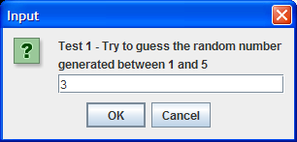 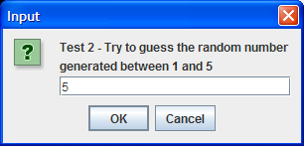

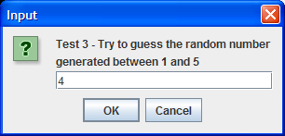 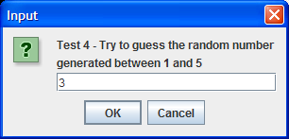

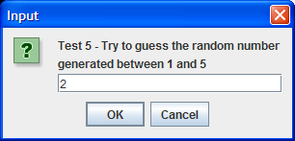 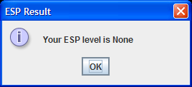

**Run 2 – The user guesses 4 or 5 numbers correct**

